Attributes | Parameter Value
Product Category | Slide Switch
Rated Current (DC) | 3A
Rated Voltage (DC) | 125V
Rated Current (AC) | 3A
Rated Voltage (AC) | 125V
Circuit Structure | Single Pole Double Throw
Mounting Type | Bent pin
Mechanical Life | 10000
Switch Color | Black
Slider Shape | Rectangular column shape
Pin Style | PC pin
Operating Temperature | -40℃~+85℃
Switch Length | 13.5mm
Switch Width | 6.6mm
Switch Height | 6.3mm
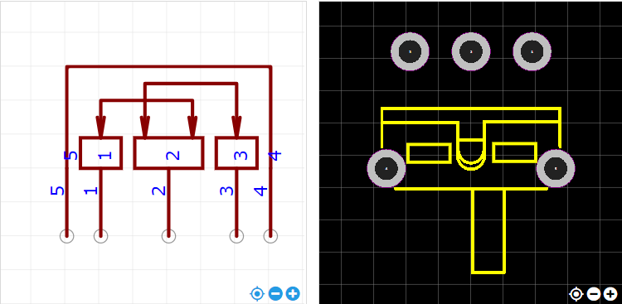
https://item.szlcsc.com/724367.html

